**Visual Representation**

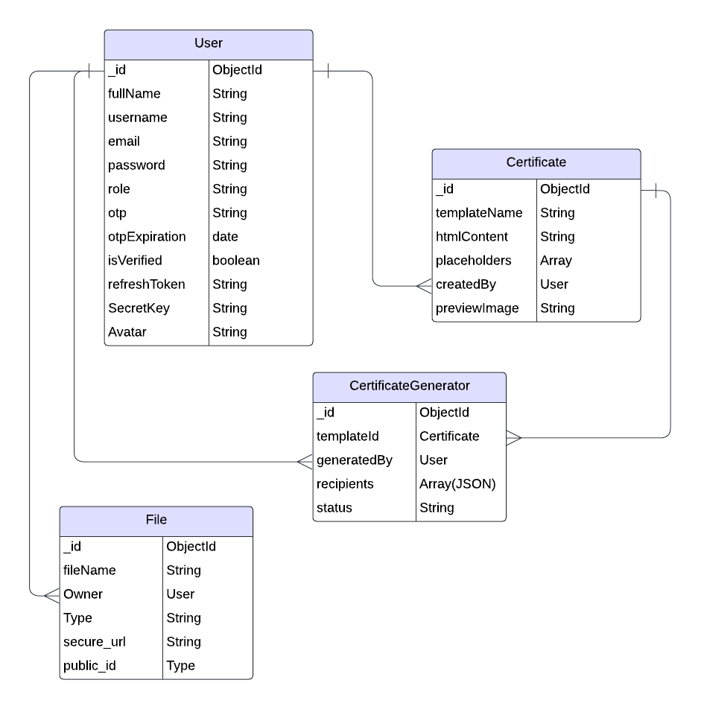

**Schemas**

1. **User Schema**

1. **Certificate Template Schema**

1. **File Schema**

1. **Generated Certificate Schema**

**Queries**

**Authentication Queries**

* **Find user by username:**
* User.findOne({ username });
* **Create new user:**
* const newUser = new User(userData);
* newUser.save();

**File Operations**

* **Upload a file:**
* const newFile = new File(fileData);
* newFile.save();
* **Find all files by owner:**
* File.find({ owner: userId });
* **Delete a file by ID:**
* File.findByIdAndDelete(fileId);

**Certificate Operations**

* **Generate certificates:**
* const generatedCertificate = new GenCertificate(certificateData);
* generatedCertificate.save();
* **Find certificates by template ID:**
* GenCertificate.find({ templateId });

**Security Features**

1. **Authentication:** JWT-based authentication.
2. **Authorization:** Role-based access control (user/admin).
3. **Data Validation:** Schema-enforced validation for accurate data.
4. **Cloud Integration:** Secure file storage using Cloudinary.

**Conclusion**

CertiMeet simplifies the process of generating and distributing certificates with a robust and user-friendly backend structure. The schemas and operations ensure a smooth workflow for template creation, file management, and certificate generation.